Solvency Testing Model

by

Pedro Aguilar Beltrán.

Introduction.

Due to the increasing dynamism of insurance operation risk factors, the use of dynamic models for solvency analysis has been increasing worldwide. The use of such kind of models offers advantages to the insurance companies because allows a strategic planning based on qualitative and quantitative results, which take into account solvency implications that may be generated as a consequence of different decisions made by the company.
At a management level, the dynamic solvency models have become a very popular decision-making tool for the main markets worldwide. Likewise, from the insurance regulator's perspective, these models have been used as analytical tools to advance toward more efficient schemes of preventive supervision.

Background
Taking into account the international experience, the Insurance and Surety National Commission of Mexico (CNSF) has been developing a regulatory framework to introduce the use of Dynamic Solvency Testing Models to encourage self-regulatory practices by insurance enterprises, and at the same time strengthen preventive supervision.
In that matter, the CNSF has been working on two main issues:
- The development of a regulatory framework based on international practices; and
- The development of a dynamic solvency testing computing system (SD-CNSF), that allows a prospective analysis of both solvency and risk exposure factors.
The regulatory framework for the implementation of dynamic solvency tests for insurance companies, has been developed taking into account the following considerations:
- Promoting the use of dynamic solvency tests as decision-making tools for insurance enterprises as a means of fortifying self-regulation.
- International experience as a frame of reference.
- Focusing the regulation on preventive supervision.
- Laying down a transitory period for the implementation of the new regulation, with the aim of allowing insurance companies to adapt to the requirements.
The SD CNSF incorporates all aspects of the Mexican regulation, as well as the laws of the risk variables behavior for each insurance business line in Mexico.
Describing insurance business as a dynamic process implies the consideration of a large number of risk variables, required to simulate the behavior of the company’s current and future capital position. Therefore, the Dynamic Solvency model of the CNSF is based on mathematical and actuarial elements of risk theory required to perform stochastic processes as well as diverse projections and simulations for diverse solvency analysis.
The SD-CNSF analysis performs simulations and projections under a variety of risk scenarios in a 10-year period. The main test of the dynamic solvency system is the estimation of the insolvency probability of insurance companies. Such probability is determined through the generation of thousands of simulated scenarios based on the roles of behavior of the insurance company’s risk variables.
Next, the actuarial and mathematical foundations used in the dynamic solvency model of the CNSF -as well as the aspects related to the computing system developed to support it- will be presented. Likewise, a general explanation of the simulation of the variables’ behavior of an insurance company’s portfolio is provided in the next sections. In addition, the projections of the diverse financial variables are explained. Such projections allow the forecasting of financial statements and the estimation of the solvency margin of a company. Finally, the main characteristics of the SD-CNSF system will be presented.

Mathematical Foundations

The solvency model of the CNSF is a tool based on the following elements: (1) the simulation of the behavior of risk variables of an insurance company’s policy portfolio; (2) the projections of the financial statements, and (3) the capital requirements of the Mexican regulation.
The claims produced by each business line that insurance companies are permitted to operate in Mexico are random variables with a probability density function. Claims are simulated using the probability density function of each type of risk of the company’s insurance portfolio.
Probability density functions have been fitted using the the last five years statistical information from the Mexican market .
The statistical data correspond to each company’s claims amount for a specific business line i,(MR_{i}(t)). The claims amount is expressed as a percentage of the written premium PE_{i}(t) (loss ratio).
The loss ratio for business line i is expressed as $X_{i,}(t)$, where t refers to the observation year.
$X_{i}(t)=\frac{S_{i}(t)}{{\text{PE}}_{i}(t)}$
$f_{X}(x;α,β)=\begin{aligned}\left\{\frac{1}{β^{α}Γ(α)}x^{α−1}e^{−\frac{x}{β}} x>0, α,β>0 | \right.\end{aligned}$For each insurance business line, it was proved through statistical analysis that the loss ratio random variable has the typical characteristics of a gamma probability function, whose mathematical expression is:

The mean and the variance are expressed by the following formulas:

$$E(X)=\text{αβ}$$
$$\text{Var}(X)={\text{αβ}}^{2}$$

In this manner, the probability density function for each kind of insurance line operating in the Mexican market was obtained. For example, the density functions related to life insurance are shown in graph No. 1.

Graph 1

The loss ratio behavior for each business line is modeled by means of this kind of probability function; thus, a curve for each business line is established. (Graph 2).

A Kolmogorov-Smirnov goodness-of-fit test was performed to prove the probability distribution functions’ adequacy on each business line. The Kolmogorov-Smirnov goodness-of-fit test is based on the absolute value of the maximum difference between the sample cumulative distribution values and the hypothetical cumulative distribution

$$D_{n}=\left|S_{n}(x)−F_{0}(x)\right|$$

The Kolmogorov-Smirnov goodness-of-fit test is effective for small samples; therefore, it is acceptable to apply it on goodness-of-fit tests of claims distributions, given that the Mexican insurance market is constituted by some 70 companies, and not all of them handle every business line.

It is worth mentioning that for the purposes of the SD-CNSF system, the particular distribution functions of each business line operated by Mexican companies were not obtained, given that it is considered that the behavior of the companies’ claims by business line can be reasonably modeled by using the market density function, once that a small adjustment has been made. Taking this into consideration, when an insurance company shows a specific behavior for any business line in its insurance loss pattern, (which is lower or higher than the market’s level), a weighing form of the simulated losses has been used along with the market distribution function in the following way:

$$S(t)=\hat{S}(t)∗(1±ε)$$
Where
$$\begin{aligned}S(t)=\sum_{i=1}^{k}{X_{i}}(t)∗{\text{PE}}_{i}(t) \\ \end{aligned}$$
$\hat{S}(t)=$Market Probability Density Function
ε = adjustment factor obtained from the Company’s loss pattern, compared to that of the market.
This allows simulating a company’s loss pattern by using the market probability functions. As a consequence, the adjustment in the claims patterns allows to capture the effect on the firm’s claim trends.

The Solvency Model
The solvency model of the CNSF is integrated as follows:
The company’s capital position at time t (CAP_{t}), can be expressed as the company’s capital position at time t-1 (CAP_{t-1}) plus the capital contributions at time t (AC_{t}) plus the operation flow (profit or loss) at time t (R_{t}) .

${\text{CAP}}_{t}={\text{CAP}}_{t−1}+{\text{AC}}_{t}+R_{t} t=1,2,3\text{.}\text{.}\text{.}$,
Where:
${\text{CAP}}_{t}$ = company’s capital position at time t,
${\text{AC}}_{t}$ = capital contributions at time t,
$R_{t}$ = operation flow at time t (profit or loss).
On the other hand, the insurance company’s solvency margin at time t is obtained by multiplying company’s capital position at time t (CAP_{t}) by the portion of the allowed assets to support the minimum capital requirements (γ), minus the solvency requirement at time t.

$${\text{MS}}_{t}=γ∗{\text{CAP}}_{t}−(\text{RS}(t)−D(t))$$

$\text{MS}(t)$ : solvency margin at time t.
$γ$: portion of assets allowed by Mexican regulation, for capital matching.
$D(t)$: Other types of assets (corresponding to special reserves).
$\text{RS}(t)$: solvency requirement at time t.

The company’s solvency requirement (RS(t)) is obtained by adding the solvency requirements of the different business lines that integrate the portfolio (RS_{i}(t)):

$$\text{RS}(t)=\sum_{i=1}^{k}{{\text{RS}}_{i}(t)}=\sum_{i=1}^{k}{f(\text{PR}(t),S(t))}$$

The capital requirements ${\text{RS}}_{i}(t)$ for each business line, are calculated according to the calculation rules for the Minimum Guarantee Capital of insurance companies stated by the Mexican regulation.

The operational flow of the insurance company at time t, is calculated as the difference between inflow (premium, investment earnings) and outflow (expenses, premium reserves, ceded premium, claims) at time t:

$$\begin{aligned}R_{t}=\text{PE}(t)−\text{PC}(t)−S(t)−\text{CA}(t)−\text{CO}(t)+\text{REND}(t)−Δ\text{RES}(t) \\ \end{aligned}$$
The written premium by the company at time t (PE(t)), is obtained as the sum of the company’s written premiums in the different business lines:

$$\begin{aligned}\text{PE}(t)=\sum_{i=1}^{k}{{\text{PE}}_{i}(t)} \\ \end{aligned}$$
The premium ceded by the company at time t (PC(t)), is obtained by adding all the premiums ceded by the company for the different business lines it operates:
$$\begin{aligned} \\ \text{PC}(t)=\sum_{i=1}^{k}{{\text{PC}}_{i}(t)}\end{aligned}$$

Now, for each business line i, the loss ratio ($X_{i,}(t)$) is multiplied by the written premium (PE_{i}(t)); all results are added and thus the incurred claims at time t (S(t)) have been obtained:

$$S(t)=\sum_{i=1}^{k}{X_{i}}(t)∗{\text{PE}}_{i}(t)$$

The operational costs CO(t) and the acquisition costs CA(t), are obtained by adding the respective operational and acquisition costs for every business line operated by the company.
$$\begin{aligned} \\ \text{CA}(t)=\sum_{i=1}^{k}{{\text{CA}}_{i}(t)} \\ \text{CO}(t)=\sum_{i=1}^{k}{{\text{CO}}_{i}(t)} \\ \end{aligned}$$
Likewise, $\text{REND}(t)$ are the investment earnings at time t, and $Δ\text{RES}(t)_{t}$ is the adjustment of statutory provisions at time t, which is obtained by adding the adjustments to the statutory provisions at time t, for each business line operated by the company.

$$\begin{aligned}Δ\text{RES}(t)=\sum_{i=1}^{k}{Δ{\text{RES}}_{i}(t)} \\ \end{aligned}$$
Based on this model, an insolvency situation at time t is defined when the solvency margin has a non-positive value, according to the Mexican regulation’s definition of solvency margin.

$$\text{MS}(t)≤0$$
The insolvency probability or ruin probability at time t is determined by the classic probability formula. If the number of cases (trials) N is large enough, then the number of insolvency cases n, divided by the number of analyzed cases, tends to the value of a company’s insolvency probability.
$$\text{Pr}(r)=\underset{N→∞}{\text{Lim}}\left(\frac{n}{N}\right)$$
$n$: is the number of cases in which an insolvency condition was presented.
$N$: is the number of trials.
The insolvency probability is the value that indicates to what extent the company is vulnerable to its risk factors; it is also used as a parameter to determine the company’s position compared to other active enterprises in the market.

Stochastic Processes
In the solvency dynamic model, a set of stochastic processes is performed, some of which are based on uniform distribution functions, while others are based on probability distribution functions integrated with the market’s statistics.
The mathematical fundamentals of the stochastic processes used by the SD-CNSF system are presented as follows: Graph 3 shows a representation of a real simulation of a certain company’s solvency margin, carried out by the SD-CNSF system. The dots appearing below the x-axis correspond to the insolvency cases. Their value equals the amount of capital resources required by the company.

The simulation process is based on the so-called “inversion method”, which consists in generating random numbers with a continuous uniform distribution on (0,1), and then applying the inverse of the cumulative distribution function of the loss ratio random variable.

0

0.1

0.2

0.3

0.4

0.5

0.6

0.7

0.8

0.9

1

1

5

9

13

17

21

25

29

33

37

41

45

49

53

57

61

65

Random numbe
r

(uniform dist.)

simulated insured
loss pattern

Insured loss pattern
distribution function

In the case of the gamma distribution, it is not possible to find, in elementary terms, the inverse of the distribution function. In order to perform the simulation process, the continuous distribution function was transformed into a discreet step function, by taking constant values for intervals of length h. Therefore, the simulated loss ratio takes values on the set $\left\{0,h,2h,3h,…\right\}$. The function used for such effect is the following:

$$F_{X}\left(x\right)=\begin{aligned}\left\{\text{gamma}\left(\frac{\text{kh}}{\text{1000}},α,β\right),\text{ si }x∈[\frac{\text{kh}}{\text{1000}},\frac{\left(k+1\right)h}{\text{1000}}), k=0,1,2,\text{.}\text{.}\text{.} | \right.\end{aligned}$$

Where $\text{gamma}\left(\text{ε,α,β}\right)$ represents the distribution function of the random gamma variable with parameters α and β, valued at point ε.

Then, the probability function of this random variable is:

$$f_{X}\left(\text{kh}\right)=P\left[\text{kh}≤S<\left(k+1\right)h\right]=F_{S}\left[\left(k+1\right)h\right]−F_{S}\left[\text{kh}\right]$$

In this last expression, S represents the loss ratio random variable.

If h is small enough, then:

$F_{S}\left[\left(k+1\right)h\right]−F_{S}\left[\text{kh}\right]≈{\text{hf}}_{S}\left(\text{kh}\right)$.

For simulation purposes it was assumed that h= 1/1000.
Projections
To analyze the company’s solvency on short and medium term, a series of projections are performed, by means of formulas that meet the procedures of the Mexican regulation. Some values were generated by taking into account the tendency of the company’s own statistical data or they were based on the company’s business plans.
The most relevant inflows and outflows of an insurance company are presented as follows:
- Written premium (PE): the written premium at year t is a value that could be proposed by the company in according with the business plan. The written premium could also be simulated based on the historic behavior of the company’s sales in the last five years. The value of the written premium is simulated for each business line, by making the company’s premium growth rate$δ_{0}$, fluctuate within a small interval of values by using a uniform distribution with mean $δ_{0}$.
$$δ_{i}(t)={\bar{δ}}_{0}∗(1±ε (t))$$
This way the written premium of business line $i$, at year$t$, is calculated as a function of the written premium at year t-1.

${\text{PE}}_{i}(t)={\text{PE}}_{i}(t−1)∗\left(1+δ_{i}(t)\right)$,

- Retention Premium (PR): the retention premium of business lines i at year t, is calculated by applying the expression:
$$\text{PR}(t)=\text{PE}(t)∗λ(t)$$
where$λ(t)$ is the retention level of the company at year t. This retention level depends on reinsurance program at year t. The variable $λ(t)$ represents the company’s retention level of premiums at year t, and could vary within a interval of values by using a uniform distribution with mean ${\bar{λ}}_{0}$.
$$λ_{k}(t)={\bar{λ}}_{0}∗(1±ε (t))$$

- Premium Reserve (RRC). The unearned premium reserve is calculated, in the case of short term insurance, as a percentage of the retention premium. The portion of unearned premium reserve is calculated by a formula which involves the average retention premium of the last two years, that is to say:
$$\text{RRC}(t)=ω_{i}(t)∗\left(\frac{1}{2}\text{PR}(t−1)+\frac{1}{2}\text{PR}(t)\right)$$
where the parameter $ω_{i}(t)$, is calculated according to the seasonality of the company’s business portfolio, and it could vary from year to year as a random variable.

$$ω_{k}(t)={\bar{ω}}_{0}∗(1±ε (t))$$

- Premium Reserve Increment. It is calculated as the difference between the premium reserves at year t minus the premium reserves at year t-1.
$$Δ\text{RRC}(t)=\text{RRC}(t)−\text{RRC}(t−1)$$
For long-term life insurance, a forward recursion formula is applied, which involves the balance of the reserve of the previous period, the written premium during the current period, and the expected claims cost.
For long term life insurance, a forward recursion formula it is applied which involves the reserve of the year t-1, the written premium and the expected claims cost at year t.
$${\text{RRC}}_{1,t}={\text{RRC}}_{1,t−1}\left(1+i_{t}\right)+0\text{.}6{\text{PE}}_{1,t}{\left(1+i_{t}\right)}^{\frac{1}{2}}−\bar{q}\overline{{\text{SA}}_{t}}$$
$i_{t}$ : interest rate at year t,
$\overline{q}$: expected mortality rate at year t. This rate is determined with the experience of the company:
$$\overline{q}=\frac{\sum_{j=1}^{e}{\frac{{\text{Sin}}_{j}}{{\text{SA}}_{j}}}}{e}$$
where:
e: number of years of experience,
${\text{Sin}}_{j}$: Amount of claims at year j,
${\text{SA}}_{j}$: total amount of sum assured of individual life insurance at year j.
$\overline{{\text{SA}}_{t}}$: average amount of sum assured of individual life insurance at year t.
The variable $\overline{{\text{SA}}_{t}}$is calculated as:
$$\overline{{\text{SA}}_{t}}=\overline{{\text{SA}}_{t−1}}+Δ\overline{{\text{SA}}_{t}}$$
where $Δ\overline{{\text{SA}}_{t}}$represents the increment of amounts of sum assured at year t, and is calculated as:
$$Δ{\overline{\text{SA}}}_{t}=\frac{0\text{.}6\left({\text{PE}}_{1,t}−{\text{PE}}_{1,t−1}\right)}{\overline{q}}$$
- Acquisition Cost (CA). It is the amount of commissions paid by the company to the agents and other expenses related to the advertisement. The acquisition cost is calculated for each insurance business line of insurance as a percentage of the retention premium
$${\text{CA}}_{i}(t)=θ_{i}(t)∗{\text{PR}}_{i}(t)$$
The parameter $θ_{i}(t)$ may vary from year to year, increasing or decreasing its value. This variation could be simulated in a random manner with respect to the average historic value of the company’s parameter. The value of acquisition cost is simulated for each business line, by making the company’s historic value $θ_{0}$, fluctuate within a small interval of values by using a uniform distribution.
$$θ_{k}(t)={\bar{θ}}_{0}∗(1±ε (t))$$
Acquisition Costs

- Administrative Cost (CO). It is the amount of expenses related to the administration and operations of the company. Administrative costs are calculated with a formula that involves a part as fixed cost, and another part as variable cost that depends on the premium.
$$\text{CO}(t)=α∗{\text{CO}}_{t−1}∗(1+Δ{\text{INF}}_{t}))+β∗{\text{CO}}_{t−1}\left[\frac{\text{PE}(t)}{\text{PE}(t−1)}\right]$$
- Investment Earnings (PF). It is the result of the portfolio’s yield, and is calculated with a formula that involves assets and their yield rate:
$$\text{PF}(t)=\sum_{j=1}^{m}{I_{i}}(t)∗r_{j}(t)$$
The parameter $r_{j}(t)$could vary from year to year, increasing or decreasing its value. This variation could be simulated by applying a random variable, according to the observed yield rate of the investment type j, and the macroeconomic expectations of that type of investments.
$$r_{j}(t)=r_{0}∗(1±ε (t))$$
The Dynamic Solvency System
Based on the dynamic solvency model, the CNSF has developed a dynamic solvency computing system (SD-CNSF), which carries out simulations of stochastic processes based on each of the insurance business lines’ probability functions, as well as on the company’s business plan scenarios.

With the SD- CNSF three main types of solvency analysis can be performed:
- An analysis based on the insurance company insolvency probability or ruin probability, under a random behavior of their risk variables (see fig. 2)
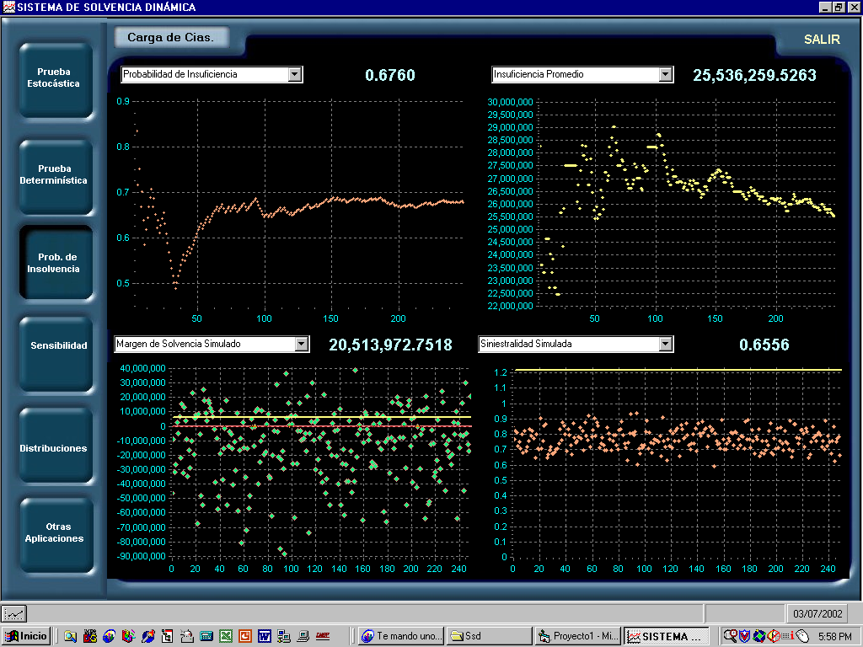

- An analysis of the short and medium term capital requirements, that the company may need. It is calculated under specific hypothetical scenarios (see fig. 3).

- A sensitivity analysis: this allows analyze the solvency margin an other variables, while facing some changes in all variables (see fig. 4).

Fig. 4
The dynamic solvency system has other special routines that complement the dynamic solvency analysis. The routines allow to know the historical behavior of the company’s risk variables as level of expenses, tendencies, indexes, assets’ investments, etc.
The development and continuous improvement of this system, will permit to have a very efficient tool in the future, for technical analysis. It will be appropriated to the specific needs of the regulators. The CNSF has foreseen that insurance companies will start delivering information in 2003, allowing the CNSF to perform prospective analysis in 2004, insurance companies will be required to have a dynamic solvency system as a prudential analysis tool. The CNSF is developing a suitable regulation, as well as standards of actuarial practice, in which the analysis will be based on.

Conclusions
The dynamic solvency system is an analytical tool, based on formal mathematical fundamentals. In addition to the model, the system incorporates specific aspects of the Mexican regulation, which increases its efficiency as an analytical tool for the regulator. This is a quite flexible system that could be adapted to diverse conditions and changes in the regulation enforcement.
The system should be periodically updated, the mathematical foundations will improve the system enhancing its accuracy and capacity to simulate the behavior of insurance institutions’ risk variables. Compared to other risk analysis measure tools, the SD-CNSF system encompasses all company’s risk variables, enlarging its scope of action.

Participation of the Actuary Pedro Aguilar-Beltrán on the Panel on Dynamic Solvency Testing Models, held as part of the 2002 IAIS Annual Conference, Santiago de Chile.
Pedro Aguilar-Beltrán is General Director of Actuarial Supervision of the Mexican Insurance and Surety Commission.
Ripley, Brian D., Stochastic Simulation, Wiley, 1987

